Chapter 12, Solution 18.

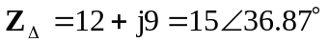

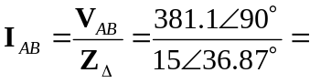25.4∠53.13˚ A

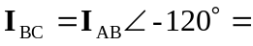25.4∠–66.87˚ A

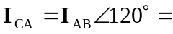25.4∠173.13˚ A

